Scenario 1: Web Service based integration through SOAPUI for Location

We are making Change of location to an employee at PS_JOB table level as below.

Pick the Employee with EMPLID🡪106253

By using update statement in backend, we are modifying the location of that employee in PS_JOB from “88287709” to “”

Navigate to the below path:

Main Menu🡪People Tools🡪Integration Broker🡪Integration Setup🡪Service

Search for the “ANZ_LOCATION_INC_DETAIL” service as below:

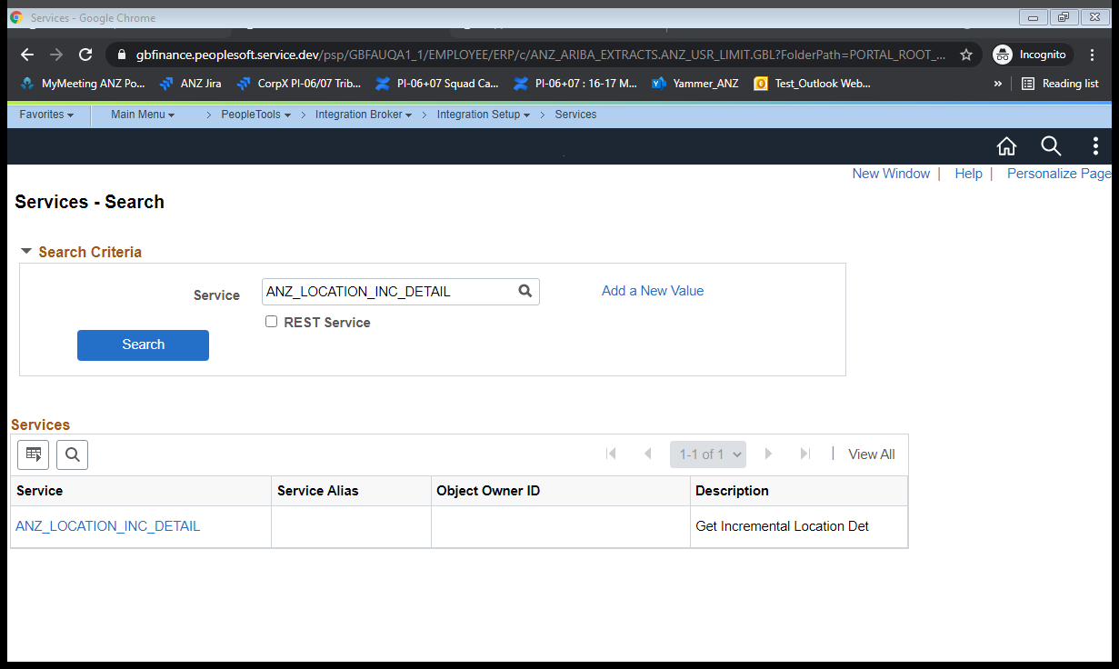

Click on Service Hyperlink

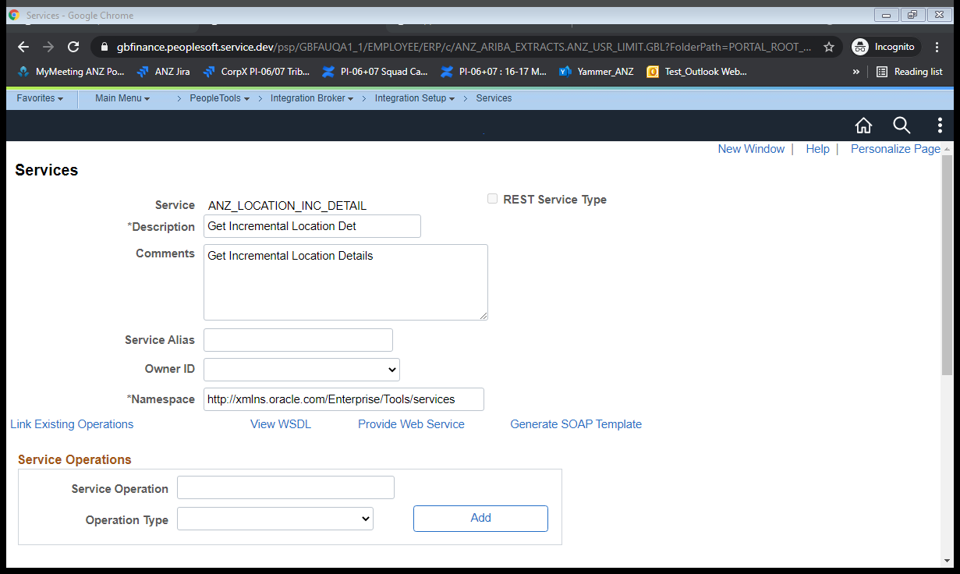

Click on View WSDL link

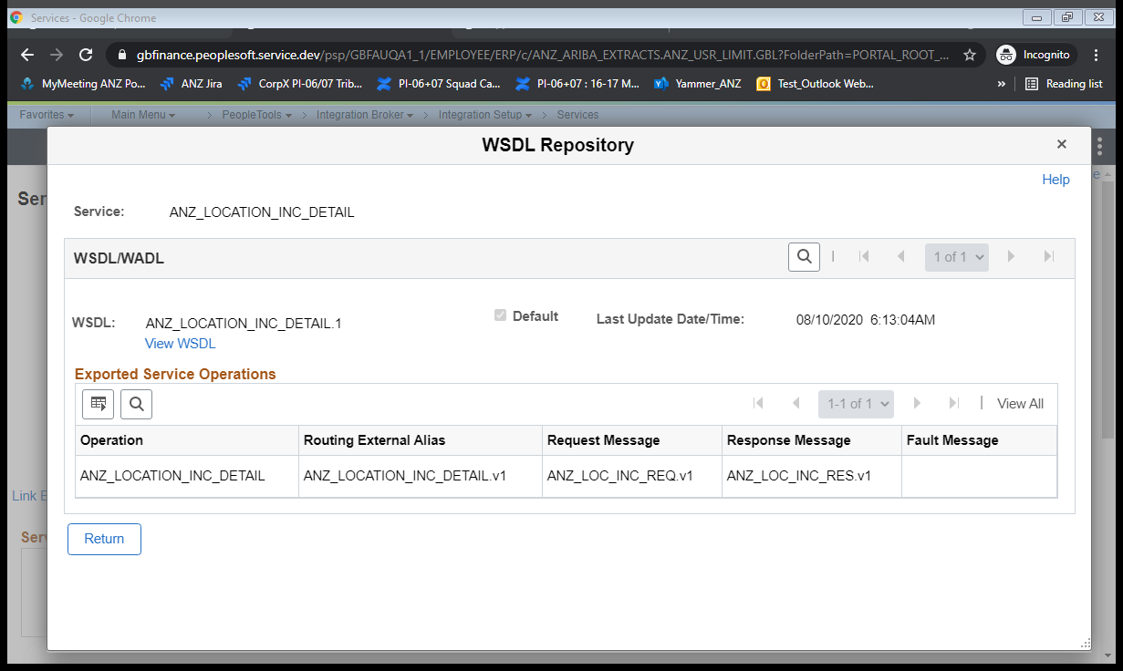

Click on View WSDL link

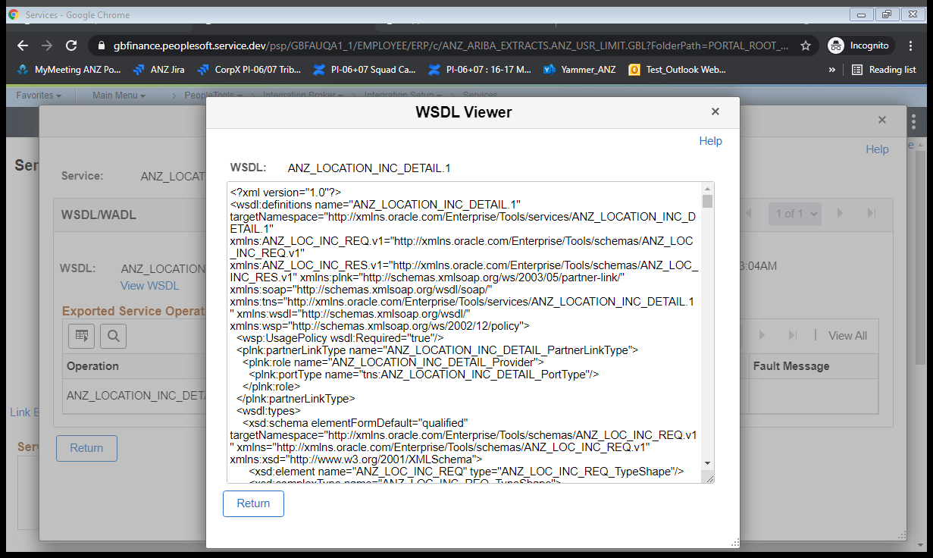

Copy the WSDL completely and save it as an .wsdl extension file as shown below:



Try loading the wsdl file in the soapUI with a project(Location) created as shown below

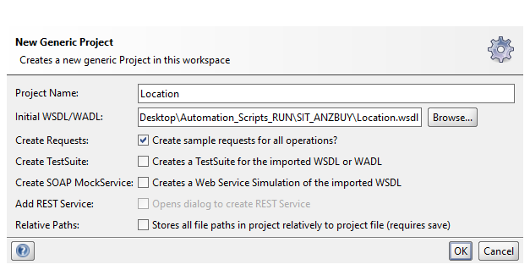

Click on OK Button and update the "from date” and “to date” as below

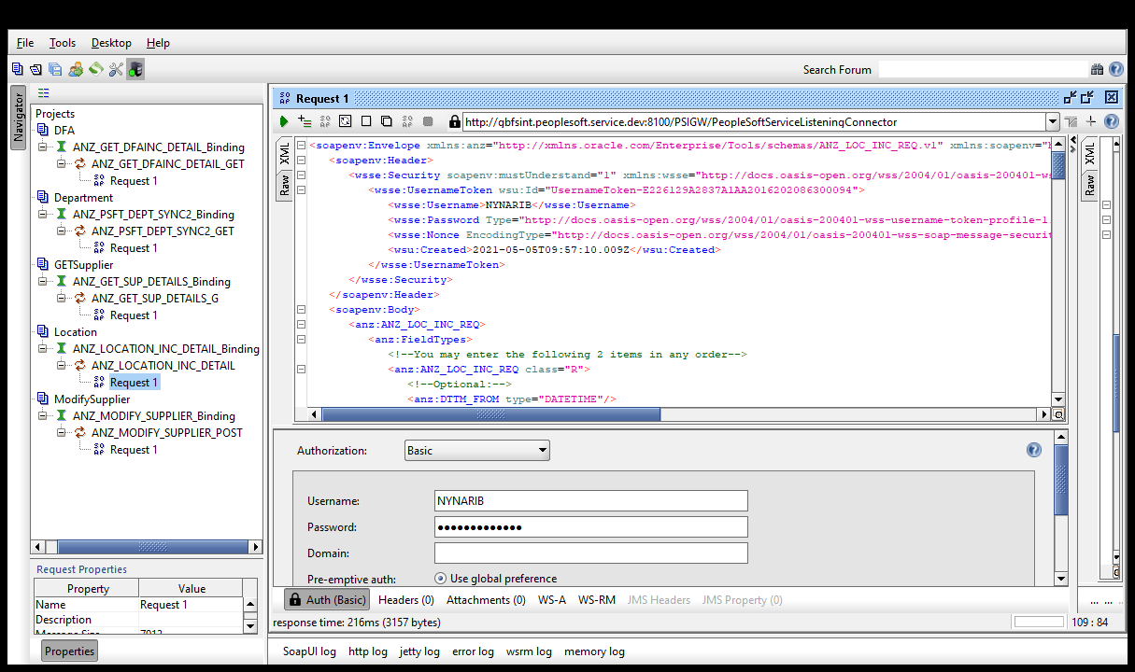

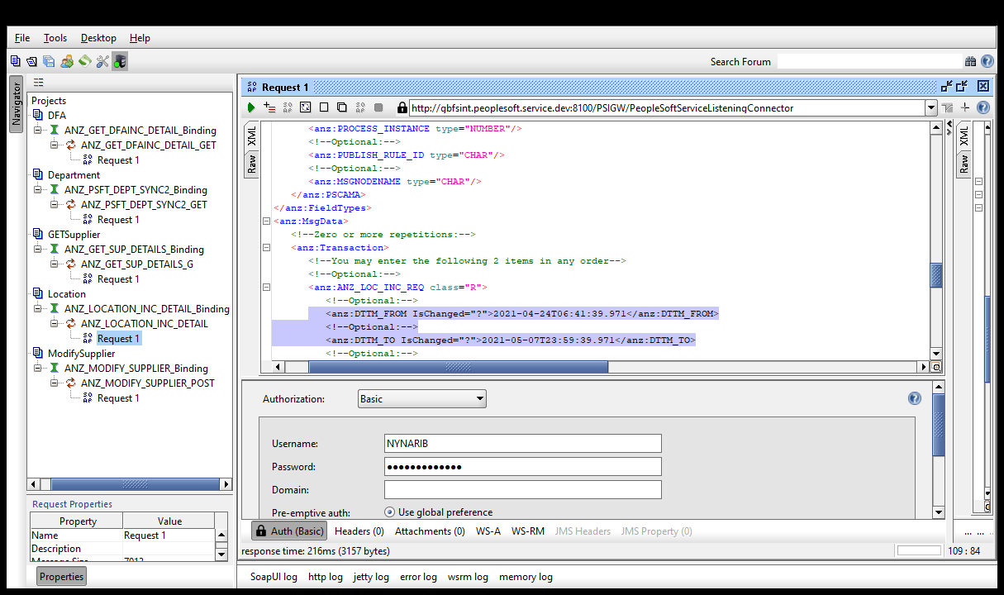

Click on “Auth” and enter the credentials and select the New authorization as shown below

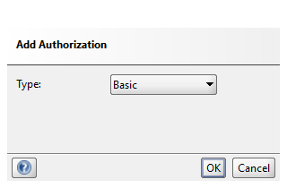

Click on OK Button

Right Click on the request tab and Click on “Add WSS Username Token” and select it as “PasswordText” as below

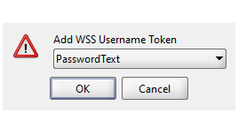

Click on “Submit request to specified endpoint URL”

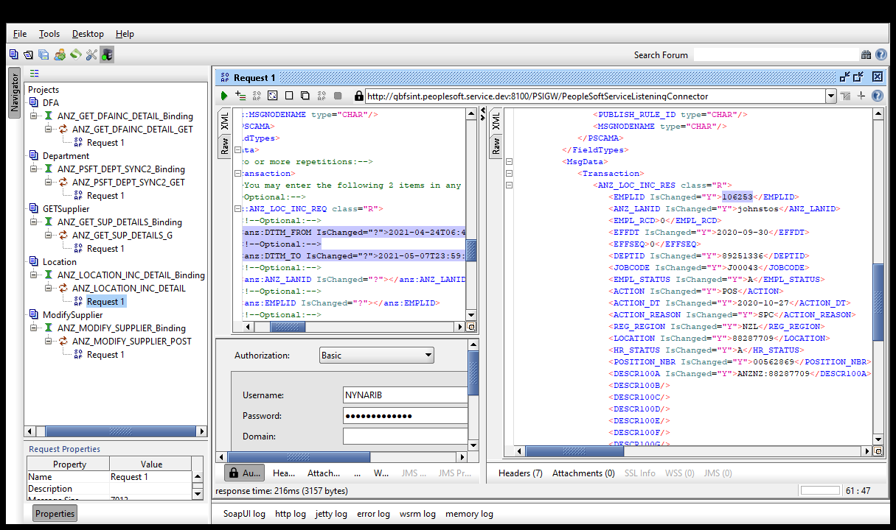

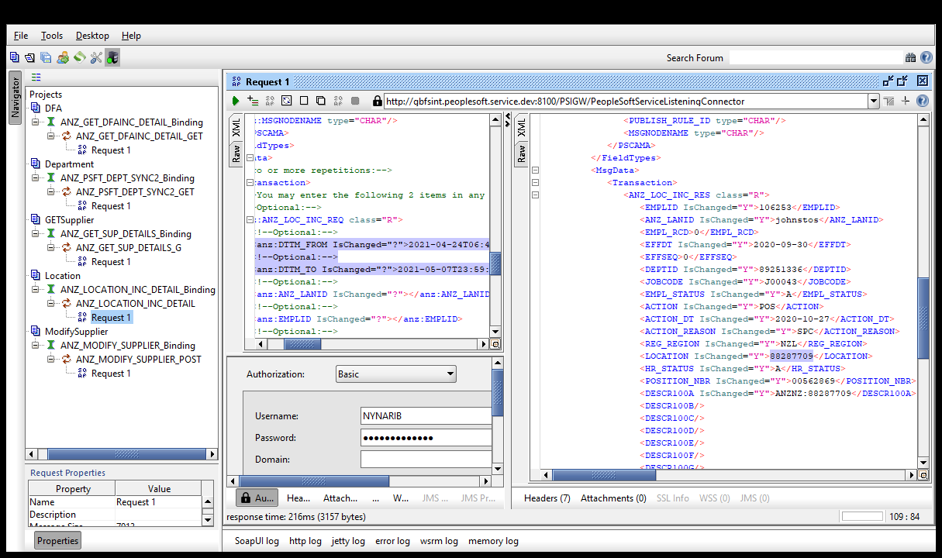

Verify the Response with the updated location details

As the Location details for that employee isn’t getting updated, Hereby, raising a Bug (<https://jira.service.anz/browse/PTPS-1037> )